Medical Terminology: The HUMAN Cardiovascular System
Due Monday, February 28, 2022
Major Grade

Directions:
You and your group will create a LIFESIZE model of the human Cardiovascular System and the Heart to locate and describe the different parts of the heart and flow of blood in/through the heart and throughout the body. You can use paper and pens/markers/craola/pencils to illustrate your circulatory system.

Step One: Create/Draw and label each part of the heart.
- Right atrium
- Right ventricle
- Left atrium
- Left ventricle
- Tricuspid valve
- Pulmonary valve
- Aorta
- Superior Vena Cava
- Mitral Valve
- Aortic Valve
- Inferior Vena Cava
Step Two: Create/draw and label the major blood vessels of the body. (See illustrations for examples)
- Right and left pulmonary veins
- Right and left pulmonary arteries
- Carotid artery
- Subclavian artery
- Brachial artery
- Renal vein and artery
- Femoral artery and vein
- Popliteal artery and vein
- Common iliac artery and vein
- Basilic vein
Step three: Color your illustrations and draw arrows that show blood flow of oxygenated (O2) and de-oxygenated (CO2) blood through the blood vessels, heart valves, and different parts of the heart and to the body/lungs and back to the heart.
Note: Oxygenated blood should be red.
De-oxygenated blood should be blue.

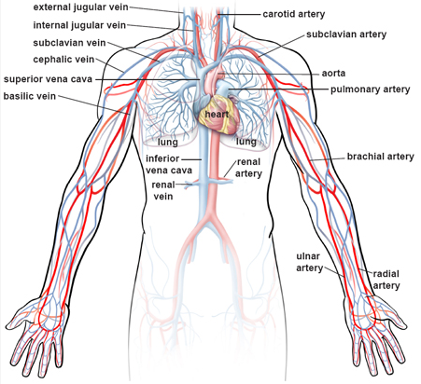
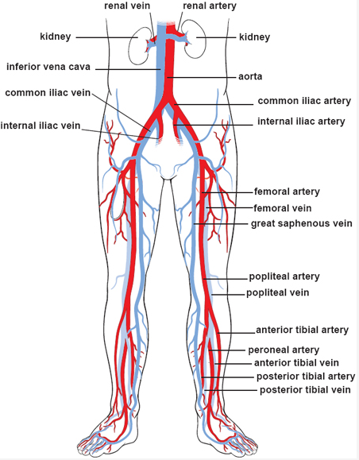

Illustrations from: Illustrations of the Blood Vessels (clevelandclinic.org)

